Assignment- EER Model
Course Registration System
The system used in my university maintains a database to track information about the students, the instructors, the courses that are being taught, their sections, the enrollments, the grades, and the academic advisors. A student has attributes StudentID, Fullname, Email, and Major, and students can take multiple course sections. There are two types of students; the undergraduate student and the graduate student. While the undergraduate students have attributes HighSchoolGPA and IELTSScore, the graduate student will have UndergraduateCollege and GREScore. There is a single instructor who teaches the section while a single instructor can also teach many sections. When the student takes the section, then the enrollment date is stored, and there is an option for assigning the grade for the particular enrollment.
Entities, attributes, relationships, keys, and the EER constructs

i. STUDENT (Superclass)
Attributes [StudentID (PK), FullName, Email, Major]

ii. UNDERGRAD_STUDENT( Subclass of STUDENT)
Attributes[ HighSchoolGPA, IELTSScore]

iii. GRAD_STUDENT (Subclass of STUDENT)
Attributes[ UndergraduateCollege, GREScore]

iv. INSTRUCTOR
Attributes [ InstructorID(PK), FullName, Department, Location]

v. SECTION

Attributes[ SectionID(PK), CourseTitle, InstructorID(FK), Semester]

vi. GRADE

Attributes [ GradeID (PK), LetterGrade ]

vii. ADVISOR- Category
Attributes[ AdvisorID(PK), OfficeHours]

viii. ENROLLS- Relationship Attributes:

EnrollmentDate

Relationships

STUDENT - ENROLLS - SECTION : This is a many to many(M:N) relationship. One student can enroll in many sections, and one section can also contain many students.

INSTRUCTOR - TEACHES - SECTION : This is a 1:N relationship. One instructor can teach many sections, while each section is taught by one instructor.

Enrollment Aggregation - RECEIVES- GRADE: The structure STUDENT – ENROLLS - SECTION represents a specific enrollment. The aggregated enrollment participates in the RECEIVES relationship with GRADE. The diagram uses N:1 relationship.

EER Diagram Concept
- Superclass / Subclass and Specialization: STUDENT is the superclass. It is specialized into UNDERGRADUATESTUDENT and GRADUATESTUDENT. The specialization is total and disjoint.
- Generalization: The double line from STUDENT to the generalization circle indicates total specialization, where all students must be part of any of the two subclasses. The d within the circle signifies disjoint specialization, where a student can be either an undergraduate student or a graduate student but not both.
- Aggregation: The relationship: STUDENT — ENROLLS — SECTION is considered an aggregation. The aggregation boundary encloses STUDENT, ENROLLS, and SECTION since their combination defines the enrollment of a certain student in a particular section. The enrolled students then engage in RECEIVES relationship with GRADE.
- Category : ADVISOR is represented by category (union type). An advisor may be from: STUDENT or INSTRUCTOR. The u circle indicates the union/category.No M:N cardinalities are indicated in these lines since they indicate the category relationship and not the binary relationship. Subset relation illustrates that ADVISOR is a subset of union of STUDENT and INSTRUCTOR.

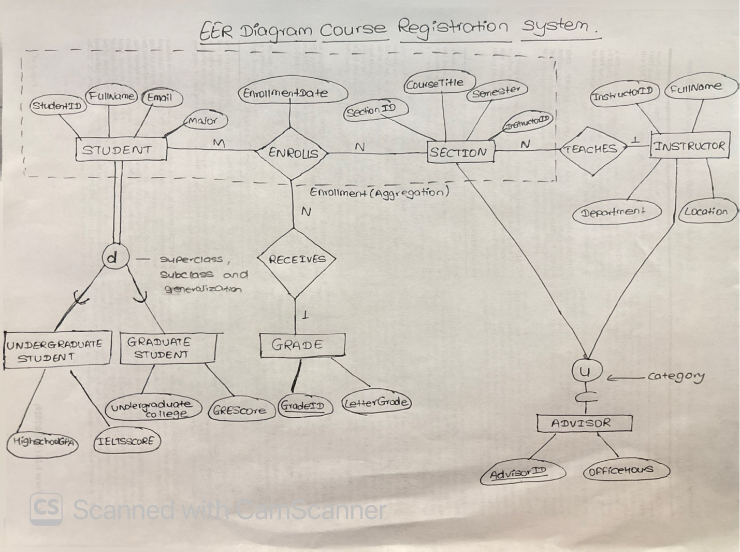

I improved the original university course registration database through the use of subclass, generalization, aggregation, and category. The entity type STUDENT is used as a superclass and then specialized into two subclasses; UNDERGRADUATESTUDENT and GRADUATESTUDENT. The specialization is total and disjoint because all students must be either undergraduate or graduate students, not both. Attributes of UNDERGRADUATESTUDENT are HighSchoolGPA and IELTSScore and attributes of GRAD_STUDENT are UndergraduateCollege and GREScore. Aggregation was implemented in relation to ENROLLS, which relates STUDENT and SECTION to show the particular enrollment of the student in the particular course section. The aggregated enrollment is then related to the GRADE through the RECEIVES relationship so that grades can be recorded. I created ADVISOR as a category or union type because an advisor could be either STUDENT or INSTRUCTOR. These ERR model made the course registration more detail along with keeping the main structure of original database

